MVP: Minimum Viable Product
- Welcome
- Agenda
- Previous MoM Endorsement of previous meeting minutes
- Planning - Roadmap Presentation of the roadmap, state of play, review and update of the implementation plan for the Vigilance module.
Roadmap from 27 April 2021:
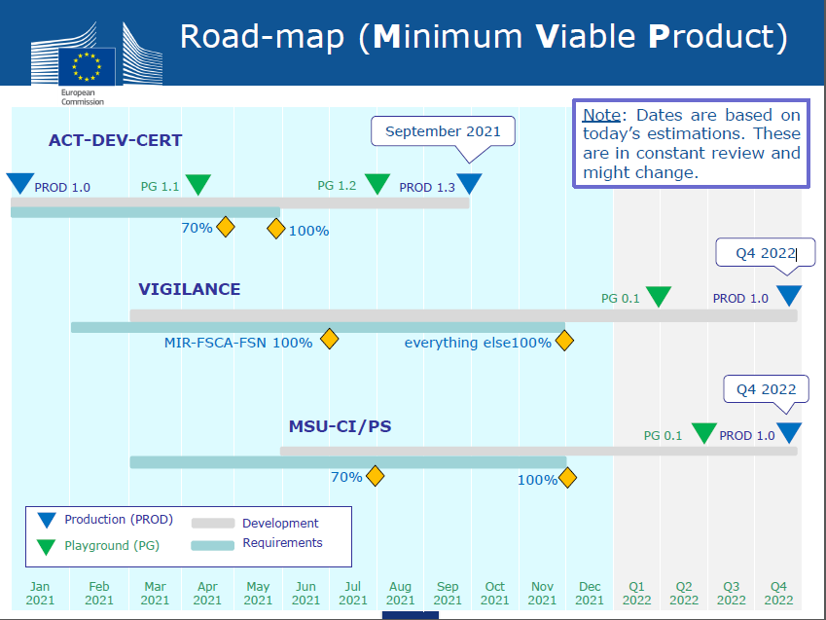
Vigilance roadmap presented on 8 July 2021:
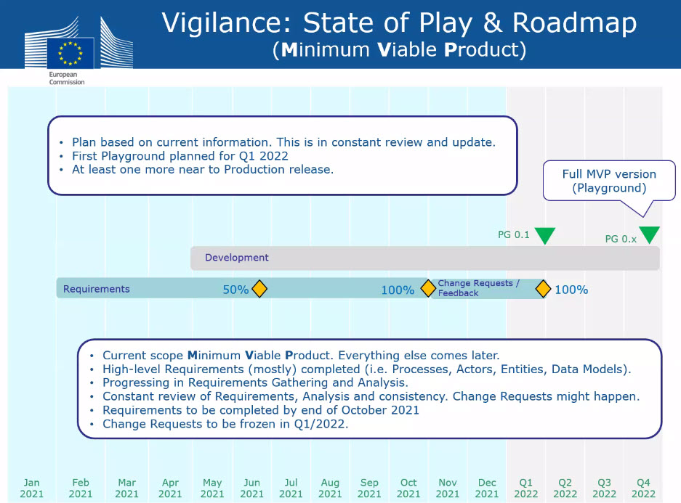
- When is EC planning to launch the Vigilance Playground? Q1 2022? Who can participate?
See roadmap slide. MedTech Europe will disseminate info when playground is open.
- Will data that is generated and submitted after the MDR DoA be required to be uploaded in the EUDAMED module once available? How will the Commission consider to do this cut off/transition?
No retrospective submission should be required (as a principle). This was confirmed during the meeting.
See MTE reflection paper to be submitted by 15 July to the MDCG/Commission:
- Which Functional Specifications (FSs) will be delivered in May 2022 in the “minimal viable product” (MVP) from the currently published Eudamed functional specifications (v4.1; Feb 2019)
No answer.
- MIR Final clarifications and demo on achievement
Changes agreed by the MDCG PMSV WG policy group will be implemented (new fields e.g. two awareness dates, issuing entities etc.)
Please refer to the MTE comments submitted on draft MIR 7.3 in Dec 2020 (no feedback, no new draft seen):
- 7.3 to be used during the transition without EUDAMED? Then 7.3.1. for EUDAMED? E.g. only EMDN will be accepted?
7.3 will be the final one to be implemented in EUDAMED.
- When the finalized data dictionary for PMSV will be released, inc. mandatory/optional indications as well as annotations re:what fields will be public?
In EUDAMED user interface for submitting a MIR: an open lock will be shown for those fields which are for the public. For the non-public fields there will be no lock or any special indication. Collaboration with the VIG transparency group planned to agree on the 7.3. MIR additional fields’ transparency.
See image:
- Will EMDN be mandatory for legacy and old devices once form submitted through EUDAMED?
From previous EUDAMED Vigilance WG meeting minutes:
COM insisted on the importance of always using EMDN as this will be used for vigilance data analysis and signal detection. Other nomenclatures can be accepted only for older than legacy and custom made devices that will never be registered in the UDI/Devices module, EMDN will be the only nomenclature acceptable for Regulations and legacy devices.
In the context of vigilance, only the most appropriate nomenclature code has to be quoted. As a device can have several nomenclature codes, the field will not be auto-populated when the device is registered in the UDI/Device module with several codes.
- How the IMDRF code changes will be handled in EUDAMED? will the changing codes be linked to the updated/newly created once (to carry out market surveillance)?
Updated codes will be released by IMDRF once a year. COM still discussing how the changes will be implemented.
- What is the implementation timeline of newly created/updated IMDRF codes into EUDAMED? 6 months?
To upload new codes right after they are released, but still keep old codes for a period of time. No agreement yet on the transition period.
- What are the rules for ‘older than legacy devices’= ‘other devices’ which are not registered in EUDAMED, should the Manufacturer assign an ID for Vigilance reporting?
The aim is to have as little legacy device data in EUDAMED as possible.
EUDAMED VIG WG minutes from 25 March 2021:
The Eudamed ID is only for legacy devices, EUDAMED will not generate IDs for the other than legacy devices that will not be registered in the UDI/Devices module. EUDAMED will not create a Vigilance devices registry, the info about such devices will only be in the vigilance reports. The information about those kind of devices will need to be provided with each report and all the info required in the current MIR will be required for other than legacy devices as the name and the nomenclature.
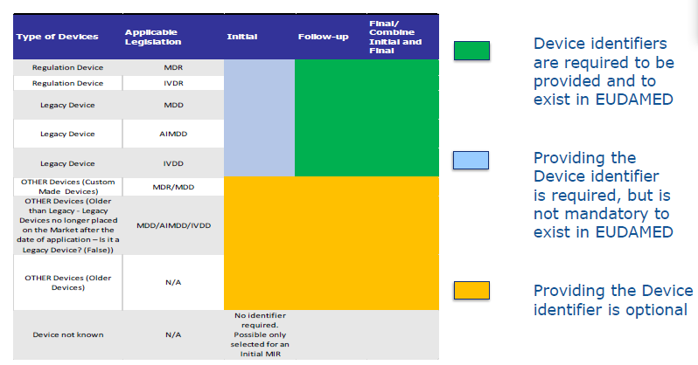
To be confirmed: the device ID (device registartion) is only to be requied by the time of the submission of the FINAL report (Regulation-compliand and legacy devices) – so the above visual should be updated.
For “old” devices: serious incidents or FSCA for ‘old’ devices (which are still in use, example: implanted or IVD instruments) need to be reported in EUDAMED Vigilance module (but the ‘old’ device is NOT required to be registered in EUDAMED UDI/Device module).
Definition of ‘old’ device: “devices placed on the market according to the medical devices Directives or the in vitro diagnostic medical devices Directive before the date of application of the MDR and IVDR or placed on the market before the Directives entered into force.”
See: MDCG 2021-13 Rev.1 - Questions and answers on obligations and related rules for the registration in EUDAMED of actors other than manufacturers, authorised representatives and importers subject to the obligations of Article 31 MDR and Article 28 IVDR
Do manufacturers of only ‘old’ devices have to register as actors in EUDAMED? Yes, manufacturers of only ‘old’ devices, which are made available on the Union market and/or are still in use, will have to register as actors in EUDAMED in case serious incidents reports or field safety corrective actions in respect of the device are requested by the Member States to be reported in EUDAMED. The obligation to register as actors in EUDAMED is applicable also, in the abovementioned cases, to non-EU manufacturers of only ‘old’ devices and their concerned authorised representatives. In case either the manufacturer or the authorised representative is not active anymore, serious incidents and the field safety corrective actions will not be reported in EUDAMED and the manufacturer or authorised representative will not have to register as actor in EUDAMED. Registered manufacturers and authorised representatives of only old devices are assigned an Actor ID that is not a SRN.
- How to handle the following case in EUDAMED: Devices (REG/Legacy/Older) for which the Manufacturer did not receive an identification number from the customer and has no time to investigate it within 15-day reporting time: shall we use the ‘older than device’ option to submit the initial report and then add the UDI/fake-UDI in the follow-up report? today ‘unknown’ can be selected in the MIR report:
It is answered by Q9. The device identifier need to be provided only for the final report.
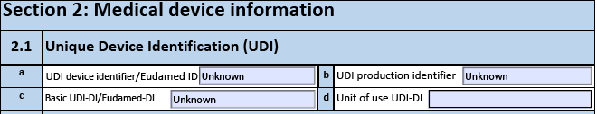
- Can a follow-up (or an updated final) report be sent after final report submitted?
Only one initial report can be submitted. Several follow-up reports can be submitted. Only updated final can be sent as a new final report (not as a follow-up).
- Will this functionality be implemented in the MVP: Make accessible and notification the CAs of any serious incident report submitted by a MF/AR, and the NB having issued a certificate for a device involved.
Access to info: yes. Notification once MIR submitted?
- FSCA & FSN
PDF print of the FSCA form content was requested by MTE and NCAs. To be examined: If it is not too complicated, this functionality will be implemented.
Final clarifications including on management of sub-status for devices
- Is EUDAMED going to automatically update the Recall Status in the UDI module from the FSCA linked to this UDI? How will be updated if more than one FSCA linked to the same UDI or product family?
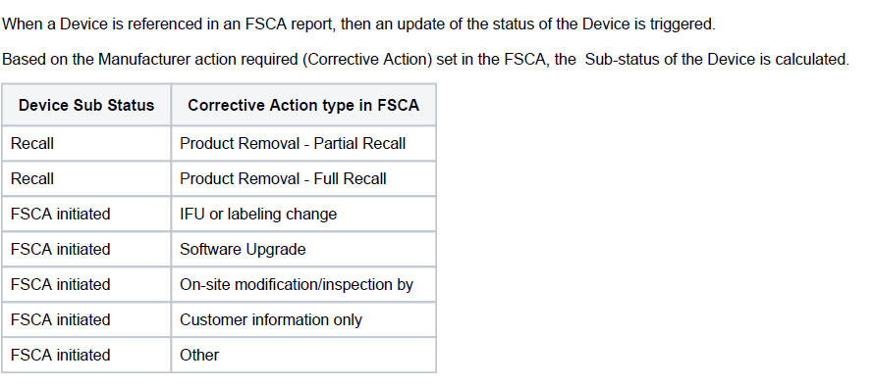
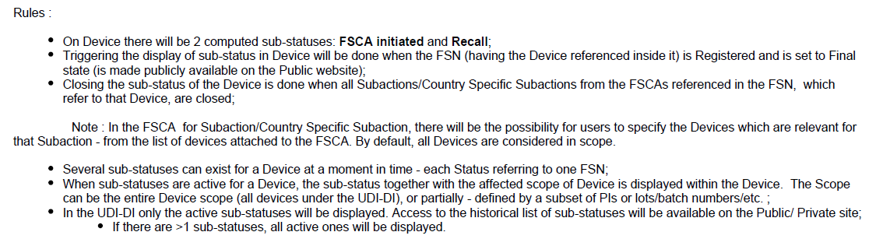
If there are two actions (Recall + FSCA initiate) linked to the same product and if captured in the same action, only the most severe one will be displayed in UDI/Device module (=recall). For displaying both, they need covered in two separate FSCAs. Two FSCAs can be linked to the same FSN.
- What is the difference between FSCA initiated and Recall?
See table just above on corrective action type decided by the manufacturer.
- What will be the official closure of an FSCA in EUDAMED? (UDI database, status of the device data field)
Substatus will be automatically lifted from UDI/Device registration module (as publicly available info) once the action is closed in the FSCA form.
MedTech Europe considerations previously submitted to the European Commission and MDCG members:
- We recommend to keep the ‘main’ status of the device / UDI-DI as ‘On the market’ unchanged unless it should be set for ‘No longer placed on the market’ or ‘Recalled’ in case of a systematic action which affects the entire UDI-DI (all lots / serial numbers / Software versions).
- In case the ‘FSCA initiated’ affects only one OR few lots / serial numbers / software version, we recommend to indicate this in a separate list with a possibility to add which lots / serial numbers / software versions are affected. Our rational: there might be several field actions happening parallel on unrelated batches which should be reflected in EUDAMED, and which should not affect the ‘main’ status of the device
- We recommend to enable a technical possibility for more than three additional fields for indicating ongoing FSCAs since many parallel actions can be in progress at the same time affecting different lots of the same device.
- We recommend that this information auto populates (lots / serial numbers / software version) when a manufacturer submits an FSCA and also the related FSN (if there is one) is linked automatically since it is not feasible to change manually every time when an FSCA initiated (possible source of copy-paste errors, different employee is responsible for data registration and for vigilance, etc.)
- We recommend that the additional fields with lots / serial number / software version information automatically dissolve from EUDAMED once the FSCA is completed (closed officially by the Competent Authorities).
- In the FSCA and FSN modules, are manufacturers going to receive confirmation that data was successfully transmitted (regardless of how will be transmitted – manually or M2M) to NCAs or NBs?
It was not discussed.
- Will FNS need to be attached by country?
Yes.
- How will manufacturer see a CA or NB comment when FSCA or FSN submitted for their review?
It was not discussed.
- Will Notified Body see comments from Competent Authorities on a specific FSCA/FSN and vice-versa?
It was not discussed.
- Will Competent Authorities be able to see all Comments from other CA in the module?
It is planned, but it was not discussed on this meeting.
- What is the timeframe required for CA to provide input not to delay communication to the FSCA?
It was not discussed.
EUDAMED VIG WG minutes from 25 March 2021:
A FSN can be very urgent and might need to be issued before the 2 days consultation period. EUDAMD could have a disclaimer/flag for urgent FSN, skipping the review process and setting the FSN directly to final and available to the public. The CAs will still have the possibility to comment.
- What is the expectation in regard to transitioning open FSCA to EUDAMED?
It was not discussed. There is no guideline yet.
- After Go Live, is the Playground be available for training purposes?
Yes.
- If EUDAMED is down, how Industry will communicate with NB and CA?
It was not discussed in this meeting.
See MTE feedback for the public consultation on draft Commission Implementing Regulation on EUDAMED
The responsibility of system failures and malfunctions should be with the EU system owner and not the users of the system. In case of the outage of EUDAMED, no fallback manual data submission should be required. Submitting reporting into the system is the only way to perform any necessary submissions in a meaningful way also supporting data integrity.
- During the meeting on 26 October 2020 for the Vigilance Module, was mentioned that there were 3 scenarios to link FSCA to FSN. We are aligned with Scenario 2 and 3, but not with scenario 1. However, our recommendation is to keep 3 scenarios to let companies to decide which one to use.
It is not yet defined. It was not discussed.
- We are not in alignment to have 1 FSCA for each action. We may have 1 FSCA for a specific Scope (products impacted) and problem, but not for type of actions (letter to remove, letter to correct). This will impact FSCA generated due to system impacted (disposable, Active Device, Software, etc.) all involved in the same problem and tied to the same Field Action Execution Strategy. Need flexibility also to reference more than 1 FSCA to the same Manufacturer Corrective & Preventive Action record.
There can be several actions in one FSCA, but to see the consequence please refer to Q13.
- Final NCAR MVP proposal review with demo
Demo was presented. The function is for NCAs only.
- PSUR Final clarifications for MVP requirements finalisation (legacy device possibly pending)
- Would a PSUR trigger an immediate registration if UDI has not been registered yet? (As the device registration timelines are later - May 2024 if a fully functional EUDAMED is released by May 2022 - than the first submission of PSUR (one or 2 years after DoA).
It was not discussed.
- FS-VGL-010.01 Eudamed functional specification state: enable to search among list of PSURs submitted by MFs (including the evaluation of the NB), PSRs – Will it be possible to list submitted PSURs, PSRs and even more?
It was not discussed. Probably not foreseen in MVP.
- PSR MVP proposal to review/discuss
- What is the timeline to develop PSR?
See roadmap above in agenda point 4. Programming is planned to be ready by Q4 2022.
The content of the form is planned to be ready by Q3 2021.
 | No. | Objective |  | Description | Timeline | Lead | CA members | Stakeholders | Links to other WGs |  | Priority |  | Status
 |  |  | Requirements for Vigilance module
4/1/2 |  |  | Integration of new Periodic Summary Reports | Development of  Periodic Summary Report | Q3 2021 | ? | ? | MedTech / COCIR |  | N/A | High | On-going

- Trend Report MVP proposal to review/discuss
- What is the timeline to develop Trend reports?
See roadmap above in agenda point 4. Programming is planned to be ready by Q4 2022.
The content of the form is planned to be ready by Q4 2021.
No. | Objective | Description | Timeline | Lead | CA members | Stakeholders | Links to other WGs | Priority | Status
1/3 | Trend report
1/3/1 | Revision of trend report | Revise the trend report for alignment on  MDR/IVDR | Q4 2021 | FI | To be defined | To be defined | IVD / CIE  MS | High | Pending

- AOB/Q & A Open questions and remaining needs for clarifications
The language of the user interface in EUDAMED can be set to any language (language of the user or authority), but the information entered will be displayed only in the language on which it was submitted.
- The FS-VGL-011.01 Eudamed functional specification states: Grant CAs of third countries or International organisations, appropriate access level to Eudamed.
It was not discussed.
- Do we know what information is being proposed to be shared with non-EU CA​s? Which non-EU CA's and organizations would have access? Only those ones that have an Mutual Recognition Agreement with the EU? Countries that recognize CE marking? Does this relate to the Public Site or some other form of sharing?
It was not discussed.
- The FS-VGL-012.01 Eudamed functional specification states: Analysis of vigilance data. What information is being monitored and analyzed
It was not discussed.

