# INTERNAL SECTION – DELETE BEFORE PUBLICATION

**Document type**

***Reflection papers****: represent a first perspective of MedTech Europe to start a discussion on a specific topic. These are generally intended for a specific audience rather than for general release (such as on the public section of MedTech Europe’s website).*

|  |  |  |
| --- | --- | --- |
| Checklist of intended audience | | Comments |
| *Internal – MedTech Europe members* |  |  |
| *Internal + – Corporate members of National Associations* |  |  |
| *External – Everybody* | x |  |
| *Specific audience – National Competent Authorities, Council* |  |  |
| *Specific audience – European Commission and institutions (e.g. ECHA, EMA)* |  |  |
| *Specific audience – European Parliament* |  |  |
| *Specific audience – Notified Bodies* |  |  |
| *Specific audience – Other associations [PLEASE SPECIFY]* |  |  |
| *Specific audience – Other: []* |  |  |

# For published document: please add as appropriate

|  |  |  |
| --- | --- | --- |
| ***- Confidential: Strictly personal -*** |  | The recipient may not share with anyone, including his/her direct colleagues. |
| ***- Confidential: For your staff only -*** |  | The recipient may share with his/her direct colleagues but not anyone outside the organisation (including members, in the case of national associations) |
| ***- Confidential: For industry use only -*** |  | The recipient may share with his:her staff and with other medtech companies/organisations (including members, in the case of national associations) |
| ***- Appropriate for external use-*** | x | The recipient may share with anyone, including individuals not from medtech companies/organisations, if he/she has a need to do so |

# A close up of a logo Description generated with high confidenceA close up of a logo Description generated with high confidenceA close up of a logo Description generated with high confidence

---------------------------------------------------------------------------------------------------------------------------------------------

# Explaining MDR transition period for health institutions

## MedTech Europe information leaflet on UDI and implant card availability

*15 July 2021*

***FINAL DRAFT for approval***

#### Purpose

The aim of this information leaflet is to explain the transition timeline when the UDI (Unique Device Identifier) information and the implant cards can be expected to be supplied with medical devices under the new law for medical devices, [Medical Device Regulation (EU) 2017/745](https://eur-lex.europa.eu/legal-content/EN/TXT/?uri=CELEX:02017R0745-20200424) (MDR), to help health institutions to navigate in the new legislative environment and to comply with any arising legal requirements.

#### Background

The [Medical Device Regulation (EU) 2017/745](https://eur-lex.europa.eu/legal-content/EN/TXT/?uri=CELEX:02017R0745-20200424) (MDR) has applied since the 26 May 2021.

To avoid market disruption and to allow a smooth transition from the Medical Device Directives (AIMDD - 90/385/EEC and MDD – 93/42/EEC) to the [Medical Device Regulation (EU) 2017/745](https://eur-lex.europa.eu/legal-content/EN/TXT/?uri=CELEX:02017R0745-20200424) (MDR), several transitional provisions are in place, including allowing devices CE marked under the Medical Device Directives to continue to be placed on the market (released for distribution) **until 26 May 2024** and made available to the end user or put into service until **26 May 2025**.

**This means that during the transition phase, devices certified under the AIMDD/MDD and under the MDR may coexist on the market,** Both will have equal status under the legislation, and no discrimination in public tenders may take place.[1]

They bear the CE marking to indicate conformance with the respective applicable law (either the MDR or the AIMDD/MDD) and are safe to be used any time; however single use devices must be used before any labelled expiry date.

### Q&A on UDI and implant card availability

1. **Which legal obligations do arise from the new Medical Device Regulation (EU) 2017/745 (MDR) for health institutions?**

A new legal requirement for health institutions arising from the MDR Article 27(9) is that they shall store and keep, – preferably by electronic means – the Unique Device Identifiers (UDIs) of the Class III implantable devices they have supplied, or with which they have been supplied.

1. **Which legal obligations may arise due to the MDR from the national legislation for health institutions?**

A requirement that may arise for health institutions according to MDR Article 18(2) and 27(9):

For devices other than class III implantable devices, Member States shall encourage, and may require, health institutions to store and keep, preferably by electronic means, the UDI of the devices with which they have been supplied. In other words, the UDI for other classes of devices may also need to be retained by the health institutions.

In addition, health institutions are required to supply to any patients who have been implanted with a device the related patient information together (patient booklet or electronic access to it) and the implant card, which shall bear its identity. Note: Some implants are exempt from needing an implant card (see page 2 [here](https://ec.europa.eu/health/sites/default/files/md_topics-interest/docs/md_implany-cards_factsheet_en.pdf)).

1. **Why are health institution getting Implant card?**

This is a requirement for certain implantable devices that are certified according to the MDR. See previous question. More details: [here](https://ec.europa.eu/health/sites/default/files/md_topics-interest/docs/md_implany-cards_factsheet_en.pdf) and [here](https://ec.europa.eu/health/sites/default/files/md_sector/docs/md_mdcg_2019_8_implant_guidance_card_en.pdf).

**Example of an implant card of MDR compliant implants:**

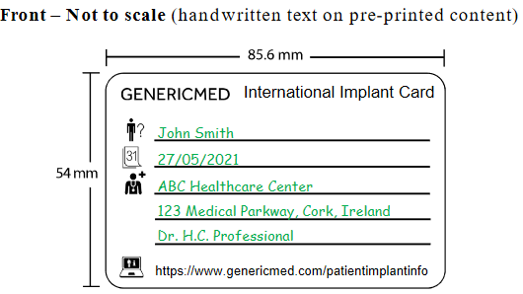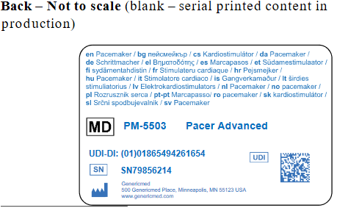

1. **What do health institutions do with the implant card?**

Health institutions must deliver the implant card to the patient who received an implant. The health institution is expected to fill in the patients’ name, date of implantation and contact of the health institution and if applicable, apply stickers to the implant cards with implant information. More details: [here](https://ec.europa.eu/health/sites/default/files/md_topics-interest/docs/md_implany-cards_factsheet_en.pdf) (page 2 Requirements and example) and [here](https://ec.europa.eu/health/sites/default/files/md_sector/docs/md_mdcg_2019_8_implant_guidance_card_en.pdf) (as of p.8 Examples)

1. **Why don't health institutions get an implant card with every implantable medical device?**

Devices certified under the AIMDD/MDD are not required to have an implant card. See: Q1 [here](https://ec.europa.eu/health/sites/default/files/md_topics-interest/docs/md_implany-cards_factsheet_en.pdf). Also, in the MDR certain types of implantable devices (certain well established technologies) are exempted from this obligation (see page 2 [here](https://ec.europa.eu/health/sites/default/files/md_topics-interest/docs/md_implany-cards_factsheet_en.pdf)).

1. **When will applicable implantable medical devices have an implant card?**

This is a requirement set by the MDR as of May 2021. The Implant card must be delivered with an implantable device that is certified under MDR, unless that device falls into one of the exempted categories. Both, AIMDD/MDD- (without an implant card) and MDR (with an implant card)-certified devices are on the market available until May 2025.

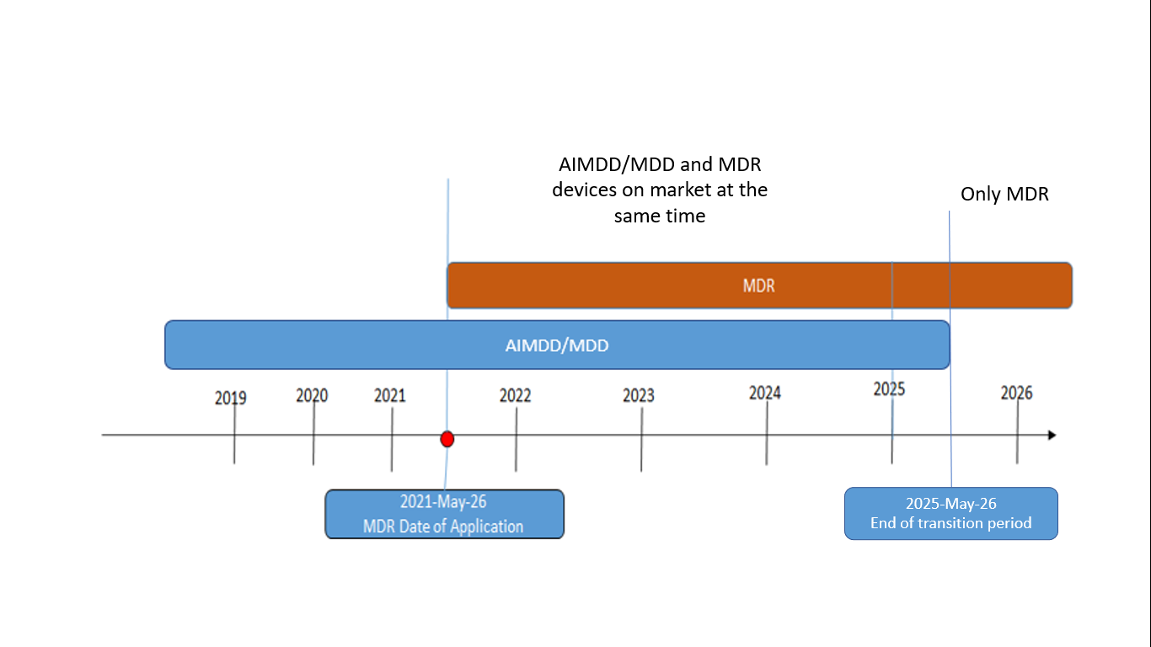

1. **Do Implant Cards need to be provided retrospectively for devices already placed on the market under the AIMDD/MDD?**

No. The relevant requirement (MDR Article 18) applies only to devices certified under MDR.

1. **What are Unique Device Identifiers (UDIs)?**

Unique Device Identifiers (UDIs) shall be used to uniquely and unambiguously identify individual devices and enhance their traceability.

The system of UDIs is the feature of the MDR (MDR Article 27). However, many devices marketed in the EU and around the globe are already labeled with a UDI due to other non-EU jurisdictions’ UDI requirements.

For further information on UDI, please see European Commission’s [UDI system - frequently asked questions and answers](https://ec.europa.eu/health/sites/health/files/md_topics-interest/docs/md_faq_udi_en.pdf).

**Examples of UDI carrier formats put on the label (scannable barcode or human readable format):**

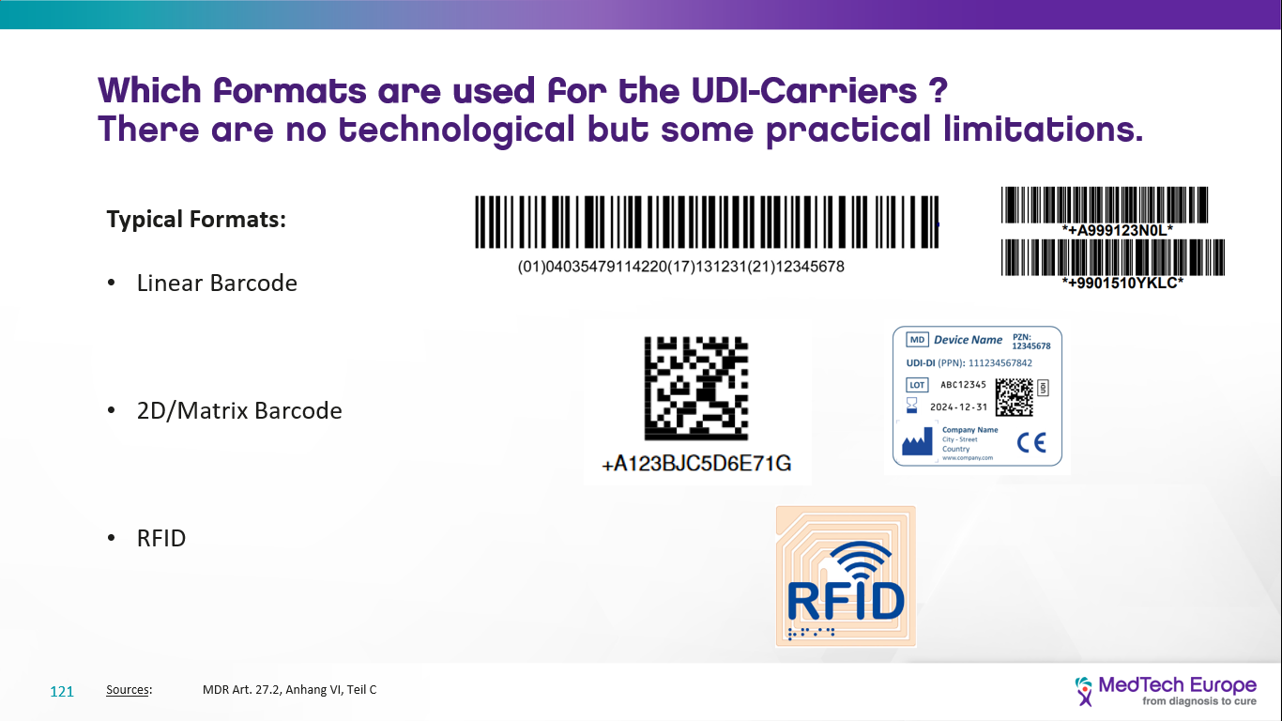

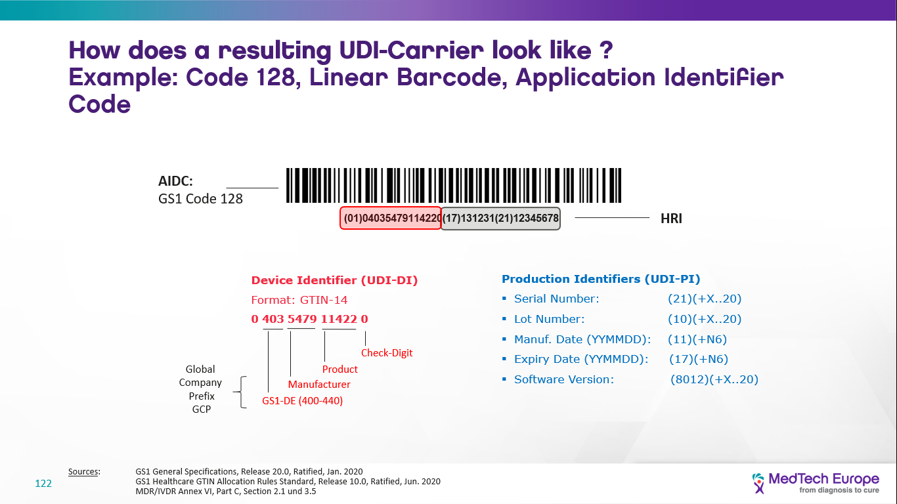

**Human Readable Interpretation (HRI)**

HRI is a legible interpretation of the data characters encoded in the UDI carrier.

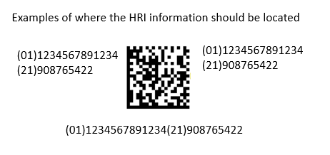

1. **Why don't health institutions receive the UDI carrier (barcode) on every product?**

Devices certified under the AIMDD/MDD may have but are not required to have a UDI carrier on the label.

You may continue seeing devices being delivered without the UDI carrier on the label until 26 May 2025 - this does not mean they are unsafe or non-compliant. They were CE marked under the AIMDD/MDD and that means they can continue to be made available and put into service until 26 May 2025.

1. **When must health institutions get UDI carrier (barcodes) on the device label?**

If not already present, UDI carriers will be added to labels in phases up to 26 May 2025 depending on the risk class of devices transitioning to MDR. See European Commission’s [UDI system - frequently asked questions and answers](https://ec.europa.eu/health/sites/health/files/md_topics-interest/docs/md_faq_udi_en.pdf). Some exemptions may apply.

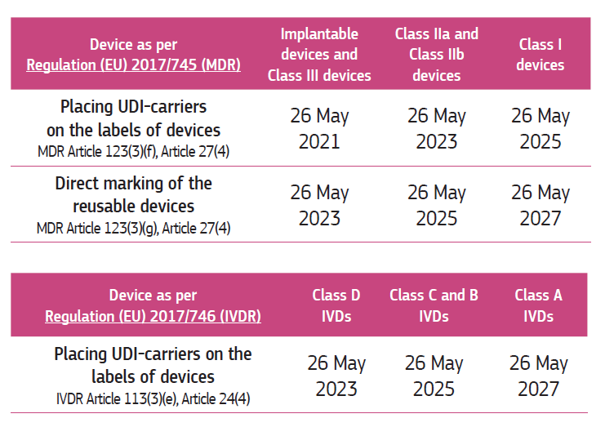

1. **Until when can health institutions use devices certified under AIMDD/MDD devices they were supplied with: do health institutions need to dispose them after 26 May 2025 or can I use them until their expiry date (if there is any)?**

AIMDD/MDD devices made available to the health institutions latest by May 2025 can be still used after that date if stored according to the label and IFU and within expiry dates (if any).

1. **If the device does not have a UDI carrier or implant card, does it mean that it is non-compliant or less safe than an MDR certified device?**

No. The device safety is indicated by the affixed CE marking which shows that it satisfies the applicable legal requirements at the time when the individual product is made available for distribution. That means the device fulfills its intended purpose and it is safe to use.

1. **Should health institutions return (e.g. returned for rework to MDR compliance), dispose of, or not use AIMDD/MDD-certified devices that do not have a UDI or implant card after the MDR Date of Application (26 May 2021 -DoA)?**

No. Use the device as normal; consult the label and the Instructions for Use. Be aware that if the individual product is made available for distribution under the applicable Directive, the requirements of the MDR will not apply.

1. **How can the personnel of a health institution tell if a device is MDR certified/compliant?**

The migration of a device compliance from AIMDD/MDD to MDR is a continuous process. The supplier (Manufacturer/distributor) may confirm the current status for health institutions. The status may be publicly queried once the central medical device database (EUDAMED) is alive.

The following features may be helpful to determine if a device is MDR certified/compliant:

* + It has the ‘medical device’ symbol on its label.  (Manufacturers may have chosen to put it already on AIMDD/MDD certified devices.)
  + It has UDI on the package label (see timelines in Question 10). Note question 15.
  + For reusable devices, it has UDI carrier on the device engraved / etched unless an exception applies. (see timelines in Question 10) Note question 15.
  + It has an implant card (certain well established technologies are exempted from this obligation - see page 2 [here](https://ec.europa.eu/health/sites/default/files/md_topics-interest/docs/md_implany-cards_factsheet_en.pdf)). Note question 15.

1. **Could a non-MDR certified device have UDI carrier or an implant card?**

**Yes.**

* + UDI-carrier on the package label – yes, because the same device may be sold in another geography that already requires a UDI carrier (e.g. US, China, Korea)
  + UDI engraved / etched on the reusable device – yes, because the same device may be sold in another geography that already requires UDI (e.g. US)
  + Implant card – yes, because the manufacturer may provide a (kind of) Implant card on a voluntary basis with the non-MDR compliant implantable device.

### Useful information sources:

1. **Regulation (EU) 2017/745 of the European Parliament and of the Council of 5 April 2017 on medical devices, amending Directive 2001/83/EC, Regulation (EC) No 178/2002 and Regulation (EC) No 1223/2009 and repealing Council Directives 90/385/EEC and 93/42/EEC**

https://eur-lex.europa.eu/legal-content/EN/TXT/?uri=CELEX:02017R0745-20200424

1. **European Commission Factsheet for Manufacturers of Implantable Medical Devices**

<https://ec.europa.eu/health/sites/default/files/md_topics-interest/docs/md_implany-cards_factsheet_en.pdf>

1. **European Commission Factsheet for healthcare professionals and health institutions**

<https://ec.europa.eu/health/sites/default/files/md_newregulations/docs/healthcareprofessionals_factsheet_en.pdf>

1. **MDCG 2019-8 v2 Guidance on Implant Card relating to the application of MDR Article 18**

<https://ec.europa.eu/health/sites/default/files/md_sector/docs/md_mdcg_2019_8_implant_guidance_card_en.pdf>

1. **European Commission’s UDI system - frequently asked questions and answers**

<https://ec.europa.eu/health/sites/default/files/md_topics-interest/docs/md_faq_udi_en.pdf>

**About MedTech Europe**

MedTech Europe is the European trade association for the medical technology industry including diagnostics, medical devices and digital health. Our members are national, European and multinational companies as well as a network of national medical technology associations who research, develop, manufacture, distribute and supply health-related technologies, services and solutions.

For more information, visit [www.medtecheurope.org](http://www.medtecheurope.org).

**For more information, please contact:**

Oliver Bisazza

General Director Industrial Policies

MedTech Europe

[o.bisazza@medtecheurope.org](mailto:o.bisazza@medtecheurope.org)

1. See: European Commission Factsheet for authorised representatives/importers/

   <https://ec.europa.eu/health/sites/default/files/md_newregulations/docs/importersdistributors_factsheet_en.pdf>

   European Commission Factsheet for Authorities in non-EU/EEA States on medical devices and in vitro diagnostic medical devices

   https://ec.europa.eu/health/sites/default/files/md_newregulations/docs/thirdcountries_factsheet_en.pdf